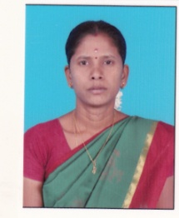

**STAFF PROFILE**

|  |  |  |
| --- | --- | --- |
| Name | : | **Mrs.B.PERIYANAYAKI** |
| Designation | : | **Sports Trainer** |
| Qualification | : | **B.A.,B.P.Ed.,M.P.Ed.,Ph.D** |
| Experience | : | **7 Years 3Months** |
| **Sports Achievement** | | |
| Represented All India Basketball Inter University Tournament (2007-2008) | | |
| Represented National Level Basket Ball Tournament (2009-2010) | | |
| Represented All India Handball Inter University Tournament (2009-2010) | | |
| Represented All India Netball Inter University Tournament  (2009-2010) | | |
| Represented National Level Basket Ball Tournament (2010-2011) | | |
| Represented All India Netball Inter University Tournament  (2011-2012) | | |